 | [INSERT NAME] COMPOSITE SQUADRON  CIVIL AIR PATROL  UNITED STATES AIR FORCE AUXILIARY | 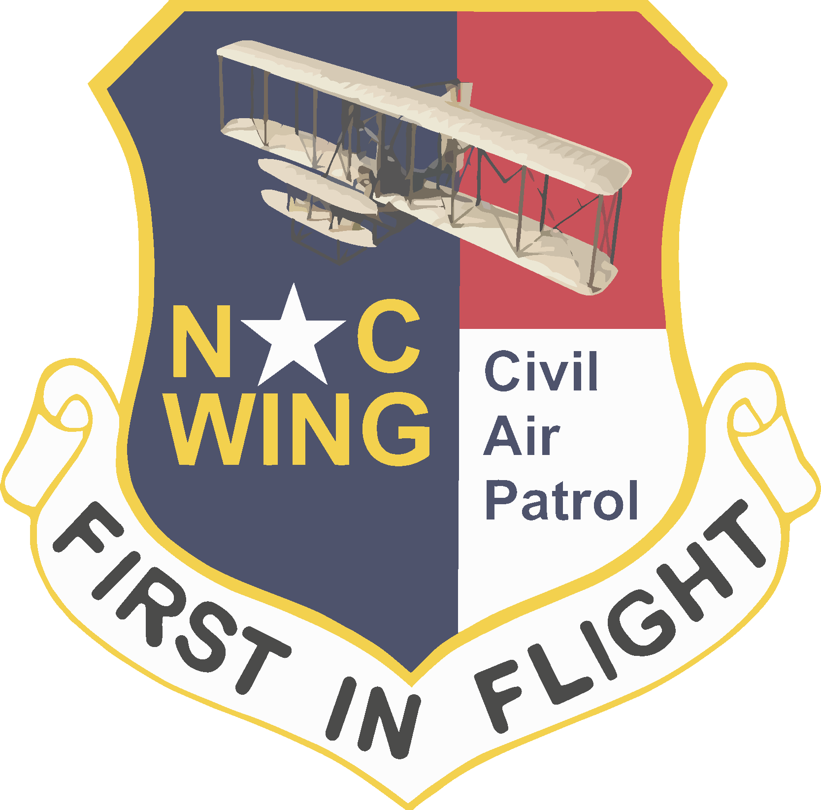

[DATE]
MEMORANDUM FOR NC[###]/CC [Group]
NCWG Promotions Board
NCWG/CC
In turn

FROM: NC[###]/CC [Squadron]

SUBJECT: Promotion of SM [INSERT NAME] ([CAPID])

- It is my pleasure to recommend that [MEMBER NAME] be promoted to [GRADE] by virtue of [FOR MILITARY EQUIVALENCY: his active duty Air Force grade IAW CAPR 35-3, ⁋ 3.4] [OR INSERT REFERENCE TO OTHER ENABLING REGULATION FOR SKILLS-BASED OR PROFESSIONAL PROMOTION AND REFERENCE TO MEMBER’S QUALIFYING SKILL/LICENSE].

- In its guidelines memo, ⁋ 5, for consideration of special appointments and mission-related skills promotions IAW CAPR 35-5, ⁋⁋ 3.1 and 4.1, the Promotions Board has determined that demonstration of performing in an “exemplary manner” should include the following. After the bolded guideline, specific information regarding [MEMBER NAME]’s fulfillment of the guideline is appended.

  - A description of the relevance of the candidate’s skills and experience for the candidate’s planned service and duty positions in CAP. [WRITE A FEW SENTENCES AND BE AS SPECIFIC AS POSSIBLE. YOU ARE WRITING FOR AN AUDIENCE THAT DOES NOT KNOW THE MEMBER BUT NEEDS TO UNDERSTAND HOW HE/SHE WILL LEAD IN CAP.]

  - A plan for completing the professional development requirements normally required for the grade to which the candidate is being promoted. [WRITE A FEW SENTENCES AND BE AS SPECIFIC AS POSSIBLE. A ROUGH TIMELINE WOULD BE HELPFUL; BOARDS NEED TO SEE THAT THE MEMBER WILL EMBRACE OPPORTUNITIES TO LEARN ABOUT THE UNIQUE CONTEXT OF CAP SO AS TO BE A MENTOR/LEADER TO OTHERS.]

  - A demonstration of capability for leadership, mentoring, and mission success commensurate with the grade sought. [EXPLAIN, IN A FEW SENTENCES, HOW THE MEMBER’S EXPERIENCE IS GREAT PREPARATION FOR CAP SERVICE.]

- I have also attached proper documentation demonstrating the member’s active duty grade [DO NOT USE MILITARY ID; WE PREFER DD-214 WITH SSN BLACKED OUT] IAW CAPR 35-5, para 3.4 [OR REQUIRED DOCUMENTATION FOR OTHER TYPES OF PROMOTIONS].

[SQUADRON COMMANDER], Maj, CAP
Commander

